Empowering Innovation and Social Impact through Collaboration
Amdocs Socio-Make-A-Thon

What is Socio-Make-A-Thon?
Facilitating the Industry-Academia Interaction through Socio-Make-A-Thon
Socio-Make-A-Thon is a platform for employees to work with young innovators from college on regional challenges that align with the SDGs of the country, allowing companies to collaboratively work alongside academia towards social innovations by extending their technical expertise.
The program has been strategically developed to enhance the synergy between tech mentors, who are valued employees, and dynamic student teams. By leveraging the collective knowledge and engagement of the community, our program effectively fosters problem analysis and ideation processes. Through the provision of technical expertise and guidance from the dedicated employees, student teams are empowered to transform their innovative concepts into actionable and impactful solutions.
Key Program Outcomes
- Fostering industry-academia collaboration and encouraging knowledge transfer between professionals and under graduates.
- Encouraging a culture of building for social impact utilising the principles of design thinking.
- 1st level prototypes of innovations with the potential to receive funds and recognition at a community level.
- Opportunity to extend mentorship for projects that reach TRL 3 and have market potential for IP creation.
ABOUT InUnity
InUnity is derived from the combination of two words Innovation and Community that contributes to this mission by nurturing compassionate, competent, engineers. We believe that educational institutions should be the epi-centre of Community Development by driving the faculties and students to contribute to it through innovations.
InUnity takes an ecosystem approach which is divided into three parts,
a) Building the mindset and fundamental skill sets of internal stakeholders
b) Right partnership with the regional communities and
c) Infrastructure that creates an environment for building impactful innovations.
These efforts ensure success stories in the short term attracting capable talents while ensuring sustained innovations over the long term.
How did we make it possible with Amdocs?
A 6 Month-long endeavour: Socio-Make-A-Thon @ Amdocs
The Amdocs Socio-Make-A-Thon united educational institutions and Amdocs to tackle regional challenges with the guidance of stakeholders and mentors. The 6-month program involved students from DY Patil University, LPF & MIT, Pune, and 10 Amdocs employees. Through a rigorous process of ideation, validation, and development, our participants have successfully generated six impactful solutions to address regional challenges. Among these solutions, three show immense promise for further development and implementation.
Selection Hackathon: Finding our problem solvers!
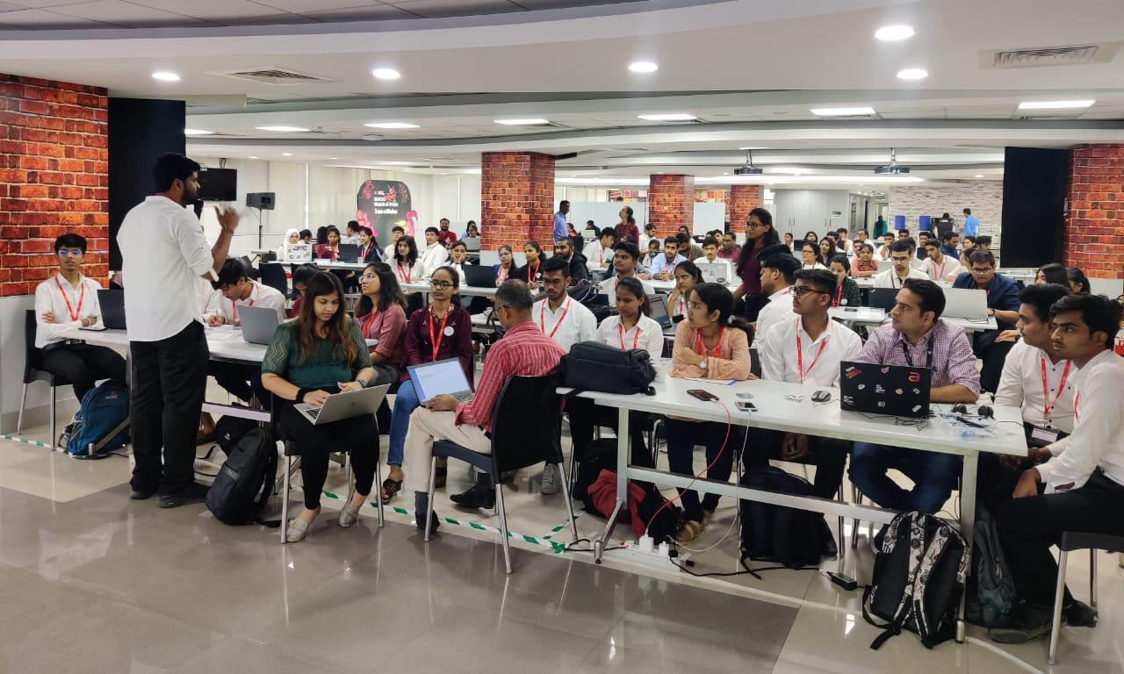
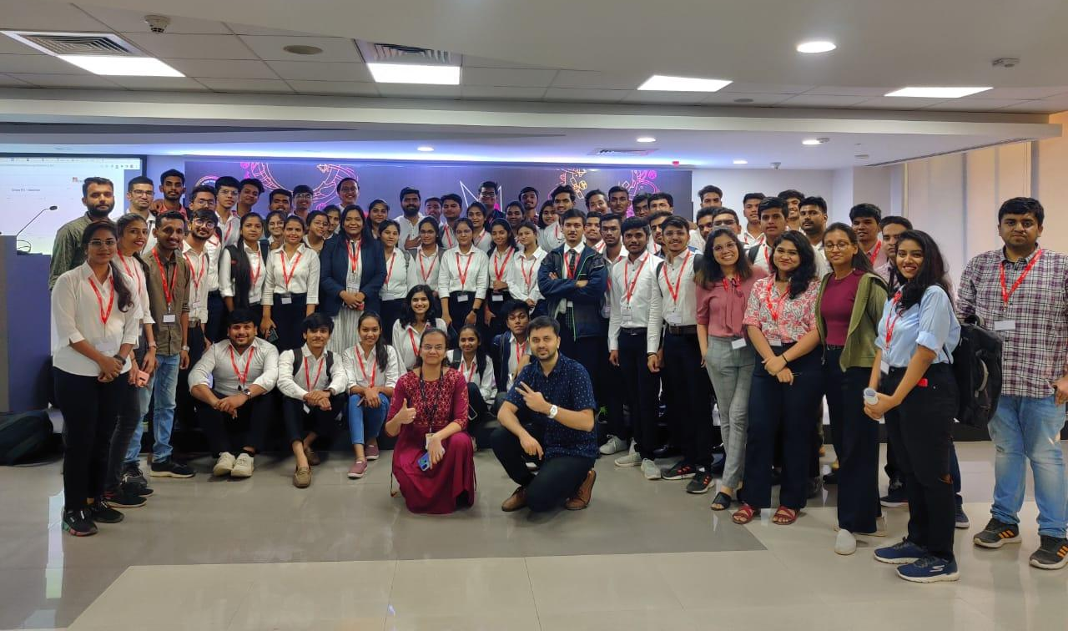
Unlocking innovation through design thinking, problem-solving, and rapid prototyping in a dynamic 2-day Hackathon open to all university students. The program saw the active participation of 110 students from various colleges and universities. These students were selected based on their passion for social impact, innovation, and their potential to drive positive change. Top performing teams were shortlisted for the next stage!

The 6-Month Cohort Experience
The 6-Month Cohort phase extended the learning and support for selected teams from the Hackathon phase. During Phase 2, the selected teams got deeper into the development of their projects. They received continued mentorship and support to refine their ideas, further develop their prototypes, and validate their solutions. This phase allowed the teams to build upon the foundation established in Phase 1 and bring their projects closer to realisation.
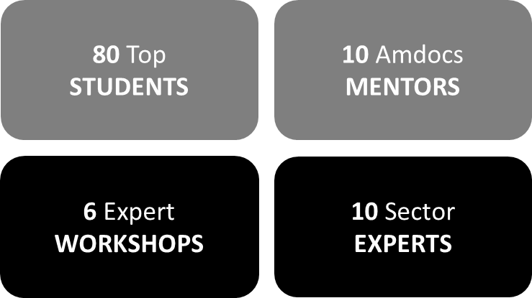
Demo Day
Highlighting progress and innovation, Demo Day marked the pinnacle of Amdocs Socio-Make-A-Thon. 30 students took the stage to deliver captivating presentations, showcasing their innovative solutions and the potential social impact of their projects.
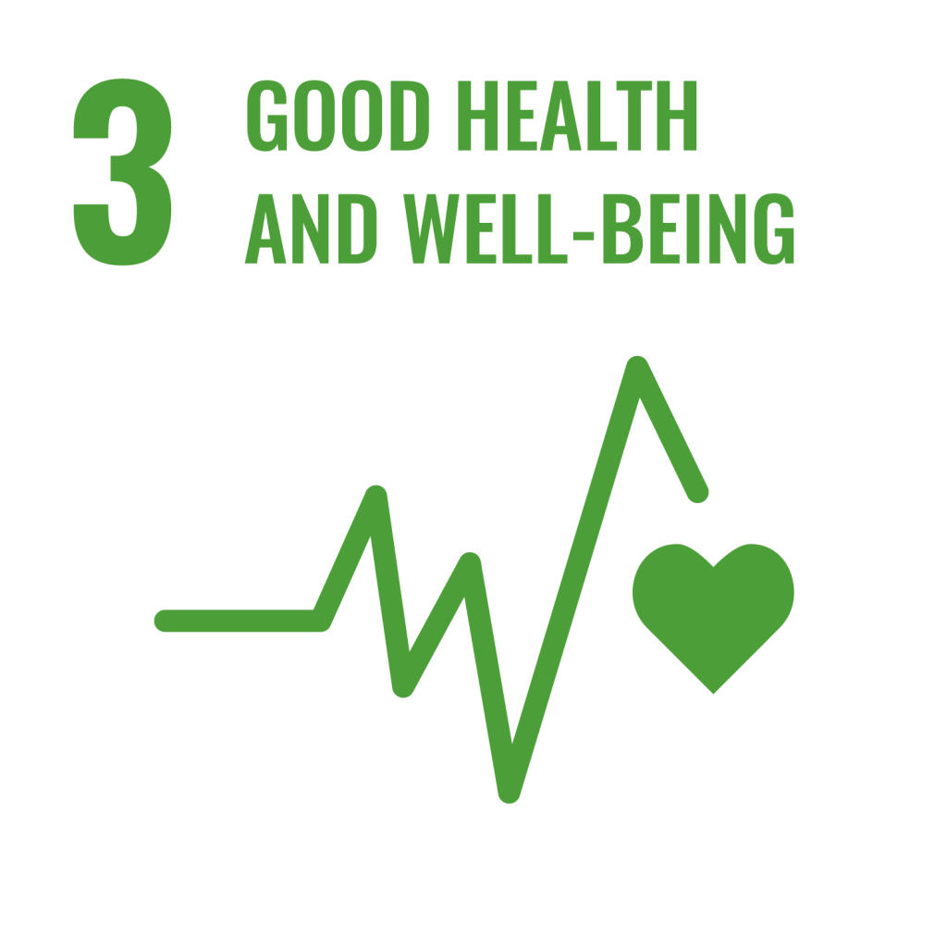
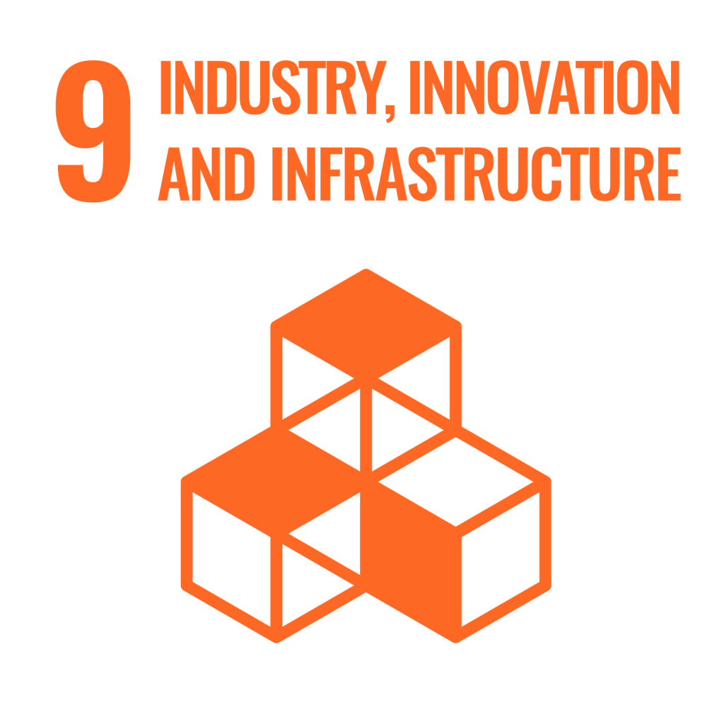
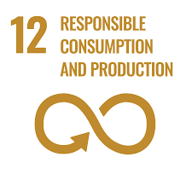
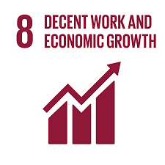
SDGs in Focus @ Amdocs Socio-Make-A-Thon

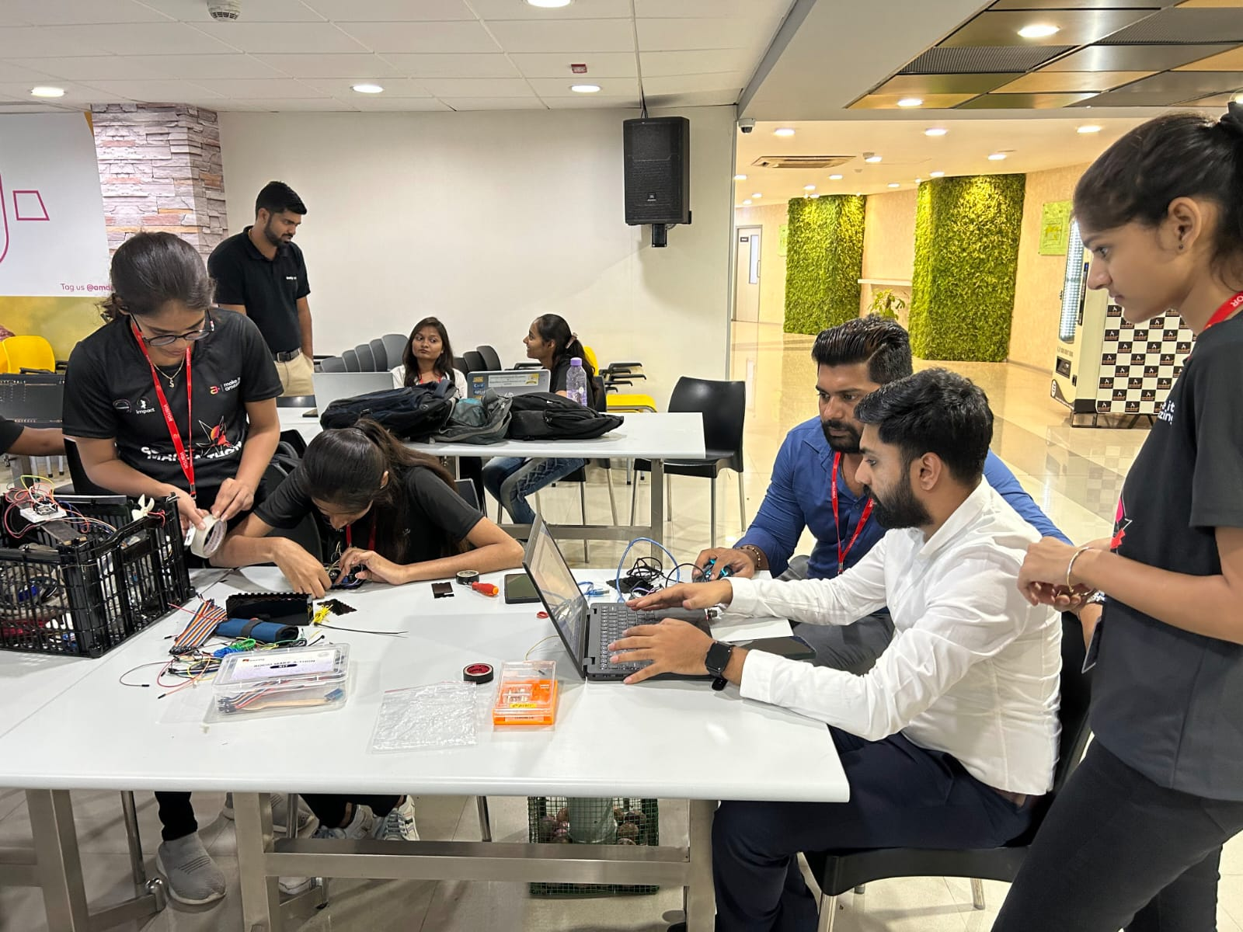
Demo Day Gallery

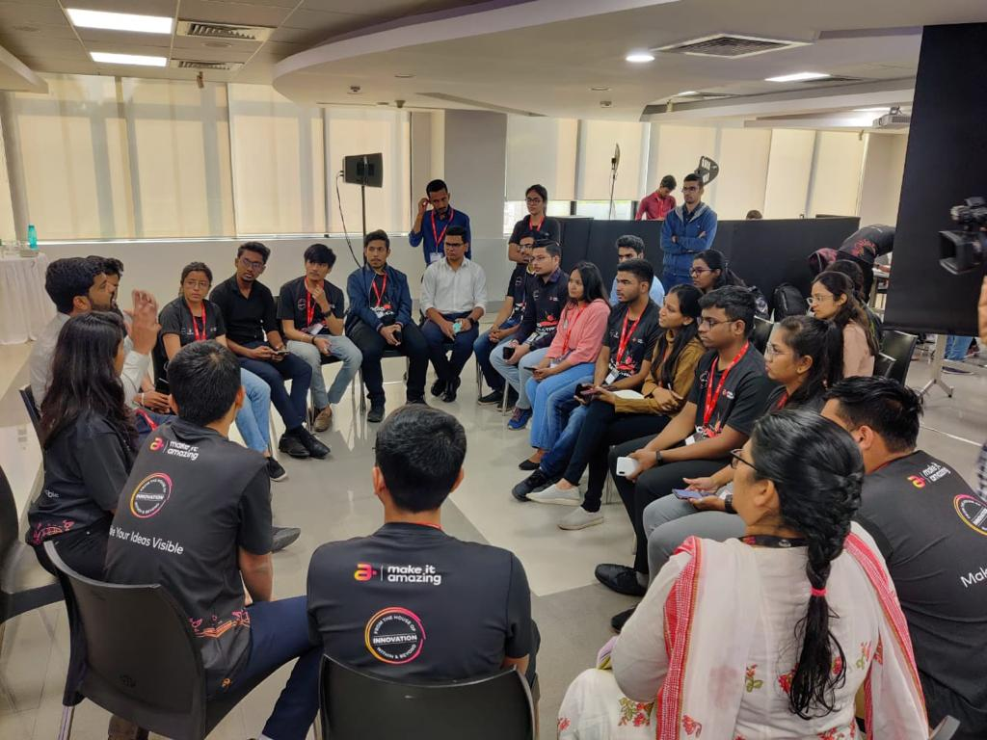

Partnering Entities
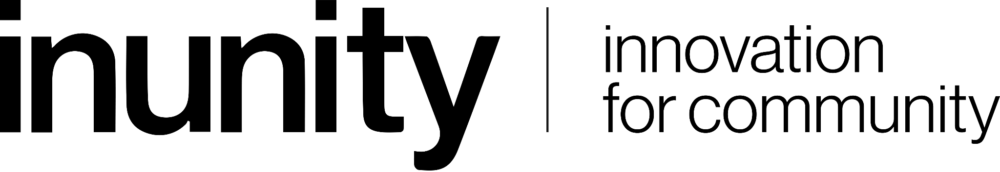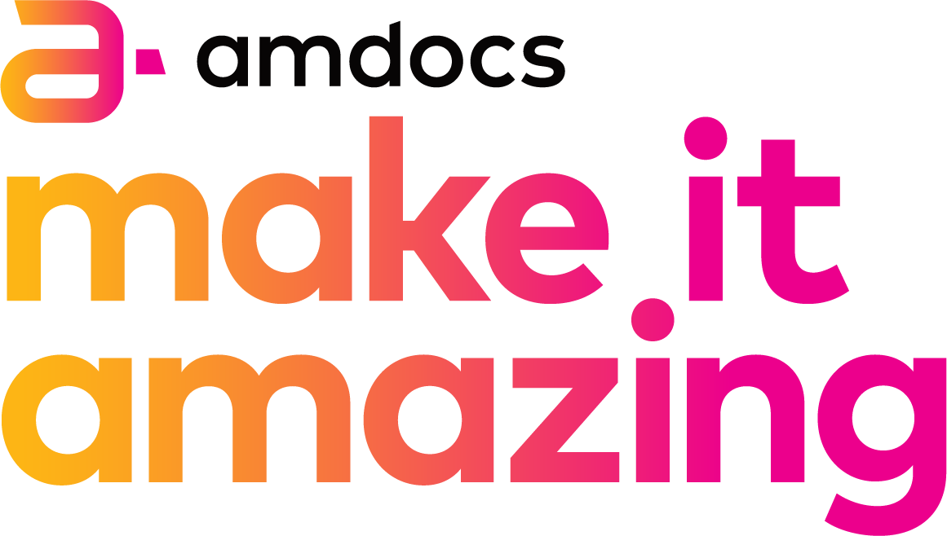

Student-Driven Impact: Problem Solving for Community Good
The student projects showcased innovative solutions addressing social challenges from the above 4 SDGs . The top 6 projects emerged from Agri and Health Care sectors.
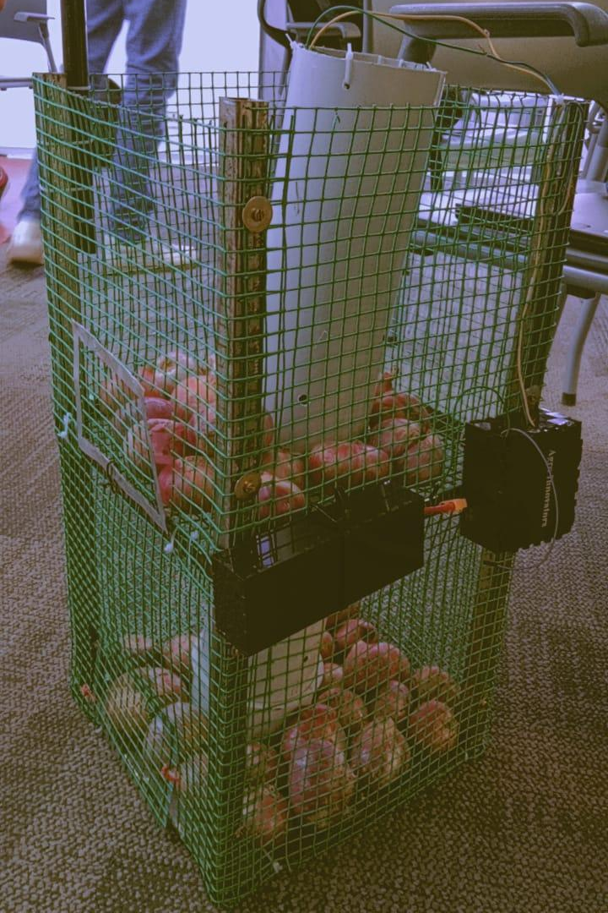
Project 1: Agriculture Sector: Tackling Produce Wastage
Smart Onion Storage: Revolutionising onion storage with a cost-effective, IoT-based solution. Their foldable storage box design preserves onions, prevents spoilage, and extends shelf life. By incorporating smart technology and effective storage techniques, they aim to minimise waste and maximise onion quality.
Impact Potential: Incorrect storage practices lead to a whopping 30-40% wastage in India due to the crop's physiological weight loss, sprouting, and rotting. This solution has the ability to bring it down to 5% if implemented at large scale.
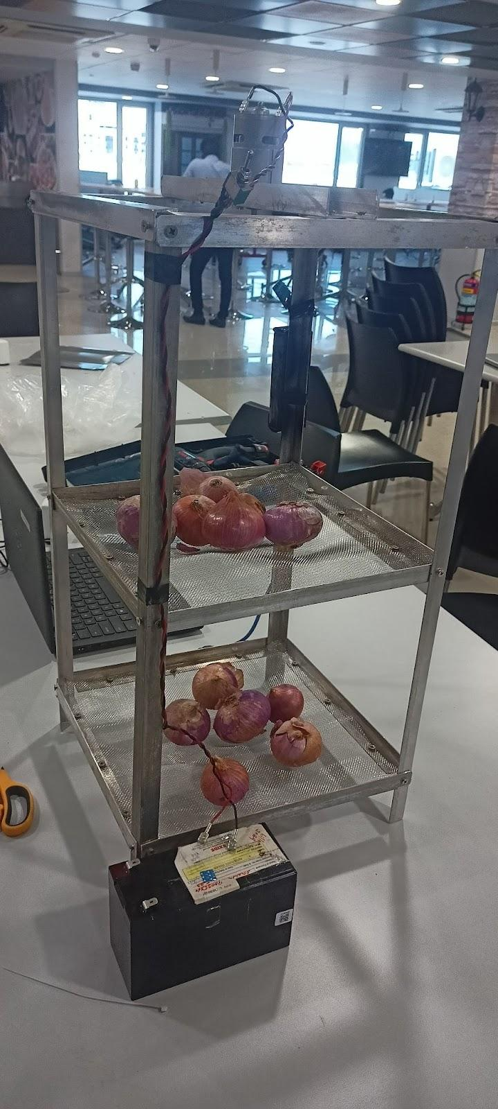
Project 2: Agriculture Sector: Tackling Storage
Agri Storage Solution: Empowering farmers with IoT-based storage technology for tropical short-day onions. Their system monitors and regulates temperature, humidity, and ventilation, minimising spoilage and maximising freshness. Enhancing productivity and profitability, this innovative solution reduces post-harvest losses for farmers.
Impact Potential: India is the second-largest onion-producing country. Storage losses of onions depend on pre-harvest, harvest, and storage conditions. Relative humidity must be continuously kept between 60-65% & stored in dark to prevent sprouting.

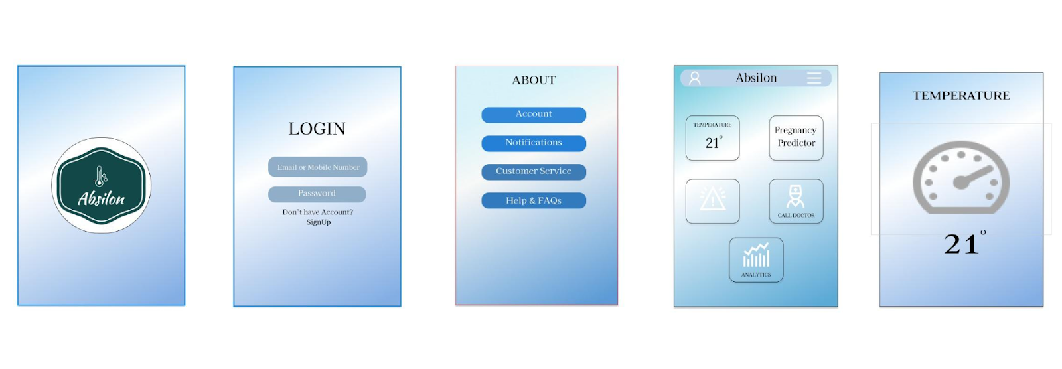
Project 3: Health Care Sector: Neonatal Care

Absilon: Innovating neonatal care with a specialised, non-invasive temperature monitoring watch. The cloth band ensures comfort and safety for newborns, while the built-in sensor continuously tracks body temperature. This real-time monitoring enables prompt interventions and enhances the well-being of infants in neonatal wards.
Impact Potential: India Neonatal and Prenatal Devices market is poised to grow at a CAGR of 5.9 % by 2028. Government of India's India Newborn Action Plan aims to significantly reduce preventable newborn deaths and stillbirths and reduce neonatal mortality and stillbirth rate to a 'single digit' by 2030.
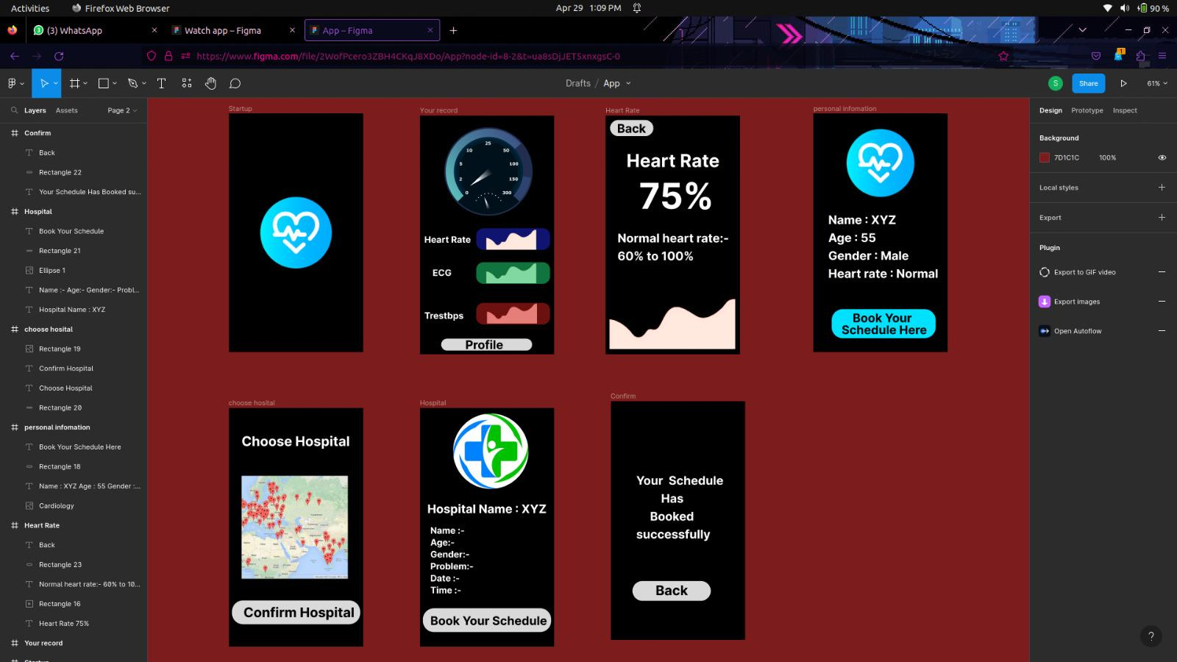
Project 4: Health Care Sector: Heart Health

Shadow Doctor: Enabling heart health through AI-powered smartwatch application. Leveraging existing sensors, the app analyses heart rate, activity, and sleep data to predict and prevent heart diseases. With personalised recommendations and automated alerts, users can take proactive measures for their cardiovascular well-being, potentially saving lives.
Impact Potential: The Indian cardiovascular devices market is expected to record a CAGR of 6.6% by 2028. In 2017-2018, the prevalence of cardiovascular diseases among adults aged 45-59 was 21.9%, 33.8% among those aged 60-74, and 37.4% among those aged more than 75 years in India.
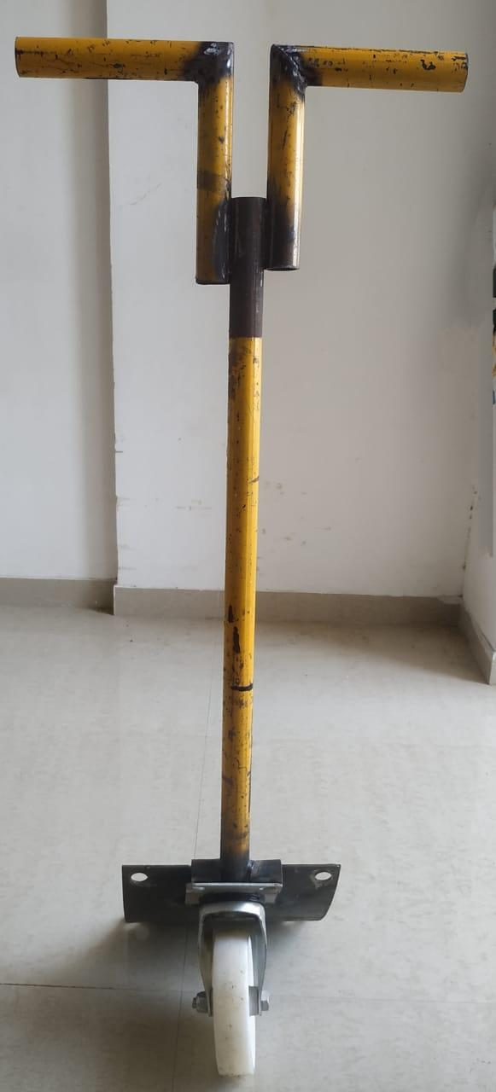
Project 5: Agriculture Sector: Loading & Unloading of Produce
Hauler: Streamlining sack handling with an innovative carrier design. The specialised carrier stacks two 50kg sacks, reducing manual effort in loading and unloading. Hauler's ergonomic solution enhances productivity, minimises strain, and optimises logistics for handling large quantities of sacks.
Impact Potential: Indian Agriculture supports 65% of the Indian population and employs 263 million workers. WHO recognizes low back pain as one of the most important ergonomic stressors and estimates that 37% of all low back pain is of occupational origin resulting in morbidity and work absence with consequent economic loss.
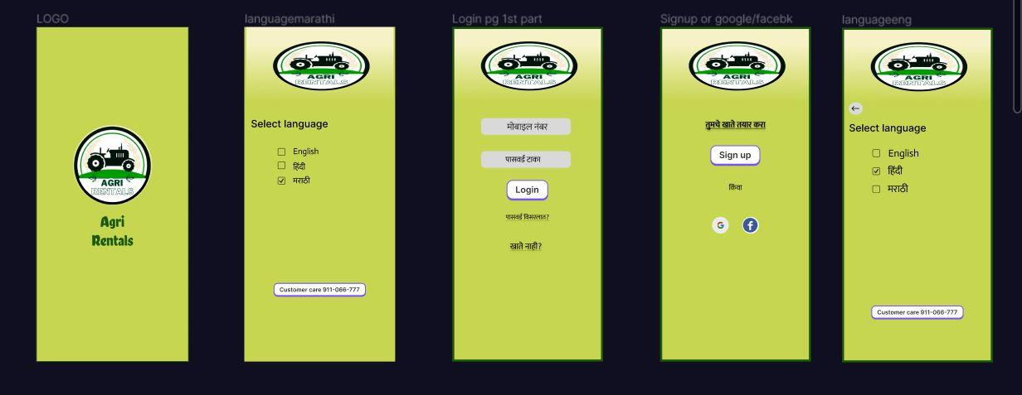
Project 6: Agriculture Sector: Loading & Unloading of Produce

Agri Rentals: Empowering farmers with a user-friendly platform for renting agricultural equipment. The website offers a wide range of tools like tractors, harvesters, and irrigation systems. By providing affordable access to advanced technologies, Agri Rentals optimises productivity, reduces costs, and supports sustainable farming practices.
Impact Potential: India’s farm mechanisation levels are low (22 % area under mechanical tillage). The level of mechanisation is 48% as against 75-95% in Brazil, Russia, USA and Western Europe.It is estimated that out of 118.9 million farming households in India, only 20 million are capable of owning machines like a tractor due to the small size of land holding, lack of irrigation and the kind of cropping pattern followed.
What our students have to say!
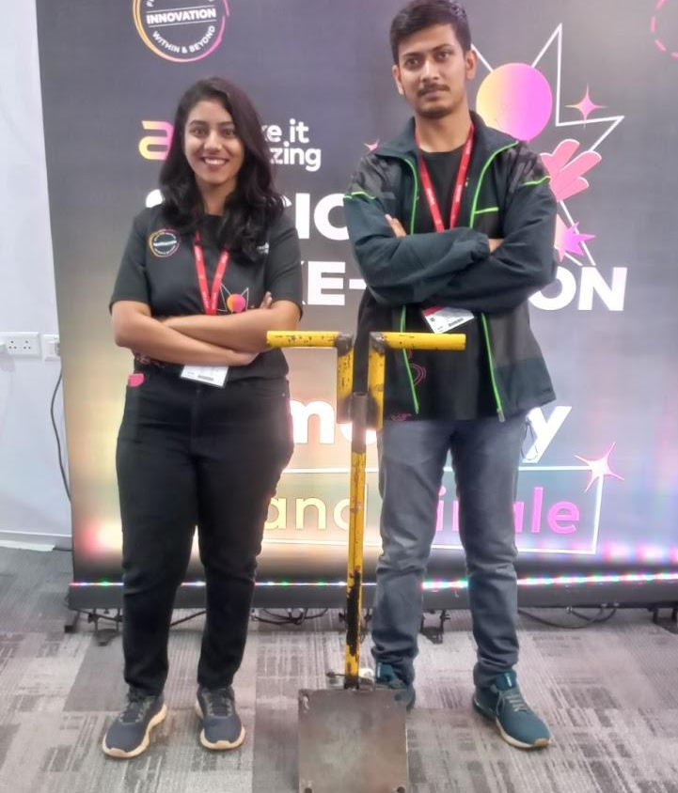
The feedback from participants of the Amdocs Socio-Make-A-Thon program has been highly encouraging and reflective of the program's impact.

“This program has helped me gain the courage to speak in front of a crowd. It has also helped me gain some other hard skills like learning OnShape, a 3D modelling software, and making a pitch deck." - Shital Chaudhari (MIT Institute of Design)

- "This program helps develop my ideation, finding solutions, creating a vision, and personal development skills as well." - Akanksha (Lilla Poonawalla Foundation)
- "This program has boosted my confidence and I have learned about many things. This knowledge will definitely help me in the future to build projects or any business idea." - Dhanashree Kailash Naykodi (D.Y.Patil School of Engineering, Ambi)
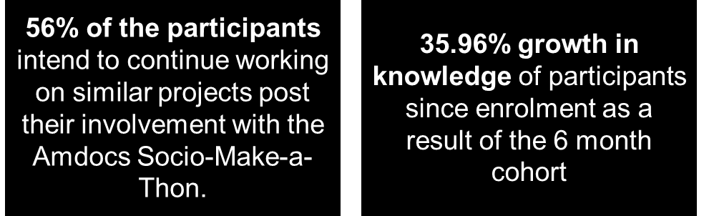
Join forces for your next CSR partnership! Get in touch with InUnity.
Contact Details Follow us for more updates
Email : hithaishy@inunity.in
Phone : +91 9481247095
Website : www.inunity.in
Mangalore Office (Main Office):
5th floor, Main Building, Sahyadri Campus,
Adyar, Mangalore- 575007

