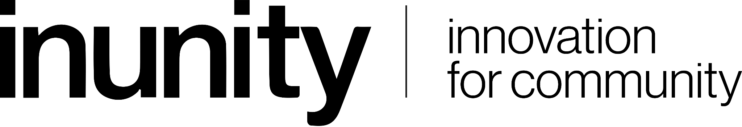

InUnity X REimagiNEWaste
Fellowship Program for a Clean Nation

About the Program

InUnity LLP in Association with Waste Impact Trust, Karnataka State Pollution Control Board & Comedkares Innovation Hub organised a REimagiNEWaste Hackathon. The 6th season of this immersive hackathon and an incubation program pioneered to co-create innovative inclusive solutions for various aspects of the waste problem. Each year REimagiNEWaste focuses on tackling one aspect of the multifaceted waste problem. The hackathon combines solving day-to-day waste issues while being inclusive in technological innovations. The top teams shortlisted in the Hackathon get into a 45-day mentorship program that brings together mentors to guide the teams to take the idea to an MVP or Startup stage.

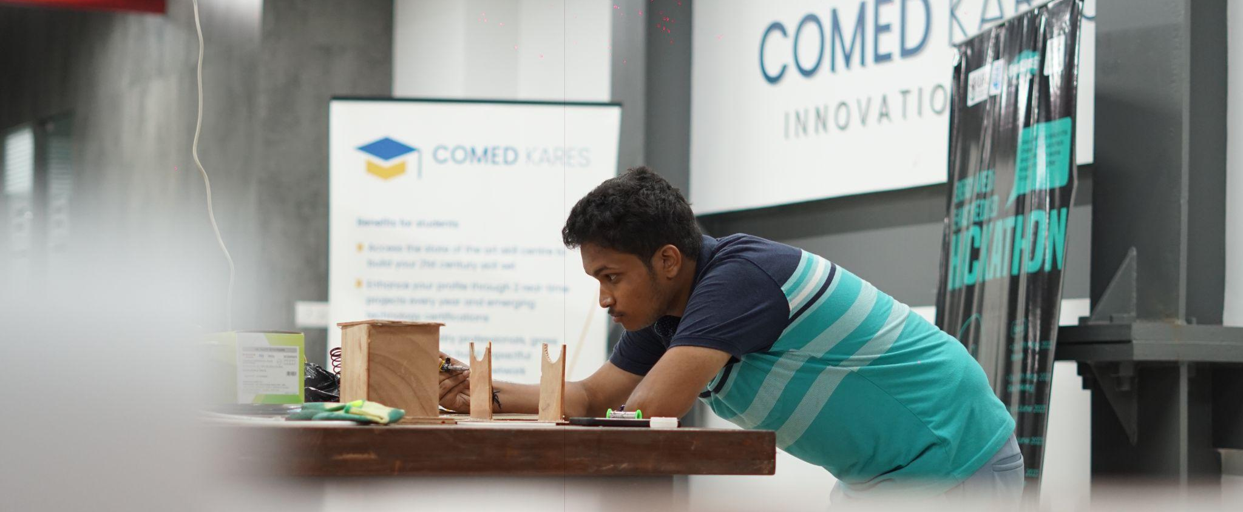

Hacking for E-Waste and Energy!
The Immersive program was spread across 2 weekends with a program plan detailed to ensure every participant builds a solution ground up that is derived from the community. The program was executed in 3 phases:
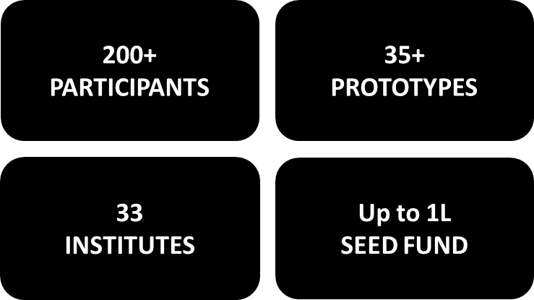
Key Highlights

ABOUT InUnity
InUnity is derived from the combination of two words Innovation and Community that contributes to this mission by nurturing compassionate, competent, engineers. We believe that educational institutions should be the epi-centre of Community Development by driving the faculties and students to contribute to it through innovations.
InUnity takes an ecosystem approach which is divided into three parts,
a) Building the mindset and fundamental skill sets of internal stakeholders
b) Right partnership with the regional communities and
c) Infrastructure that creates an environment for building impactful innovations.
These efforts ensure success stories in the short term attracting capable talents while ensuring sustained innovations over the long term.

Shedding Light on E-Waste and Energy: Raising Awareness and Empowering Action
The field visits and associated programs of the program successfully heightened awareness of Bangalore's thriving E-waste and Energy sector among 150+ candidates; with a staggering 76% of participants gaining a deeper understanding of the sector's current status.
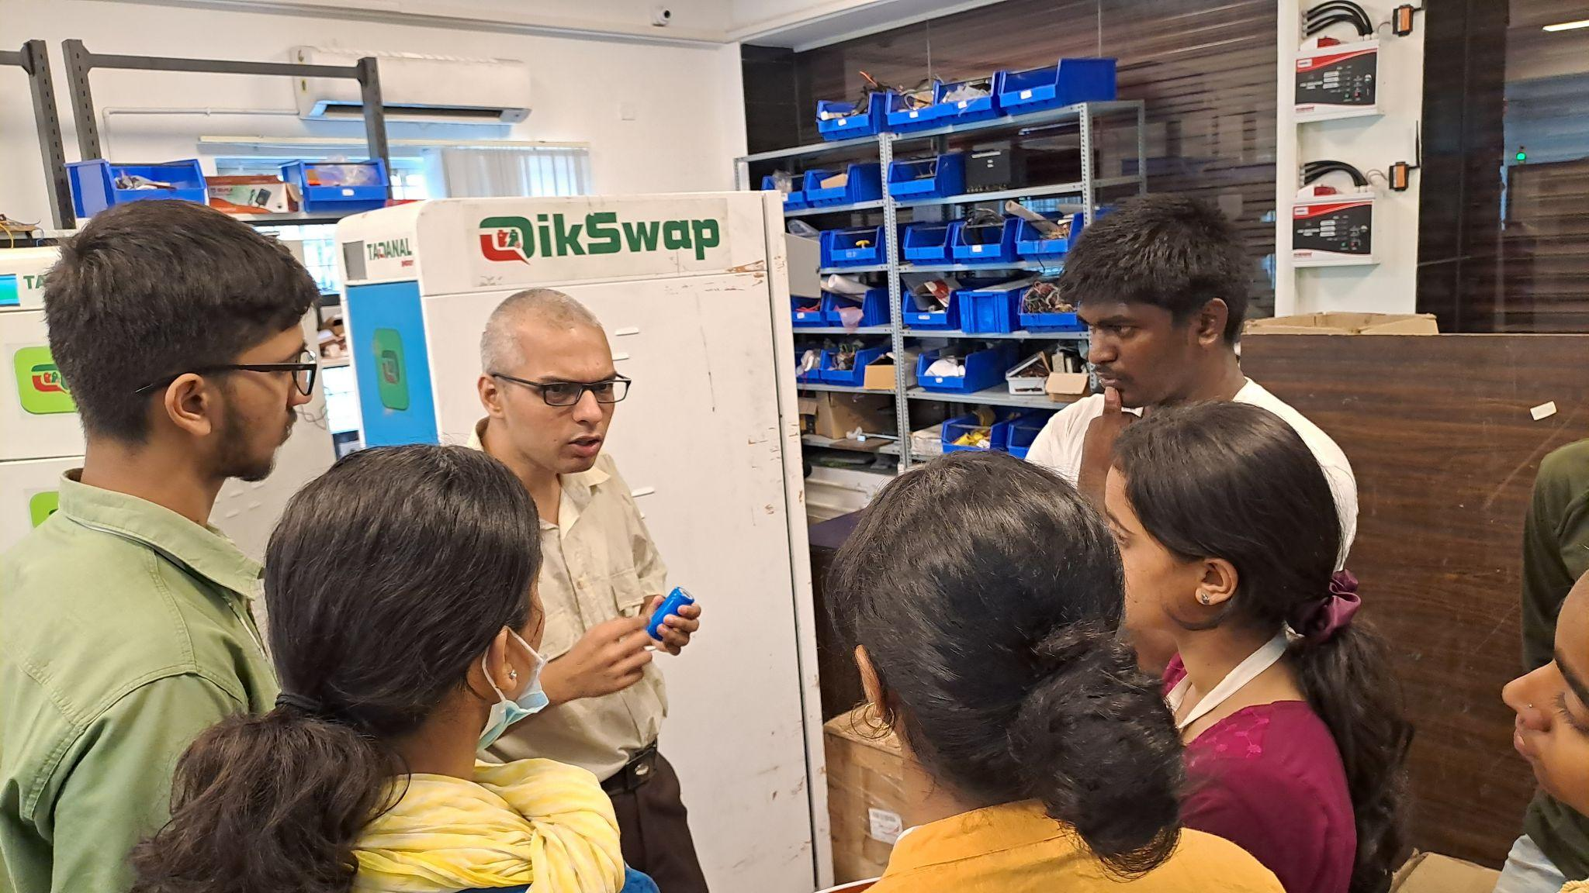

“I've experienced about E-waste management through some various kind of factories and learnt about Drainage Waste management”

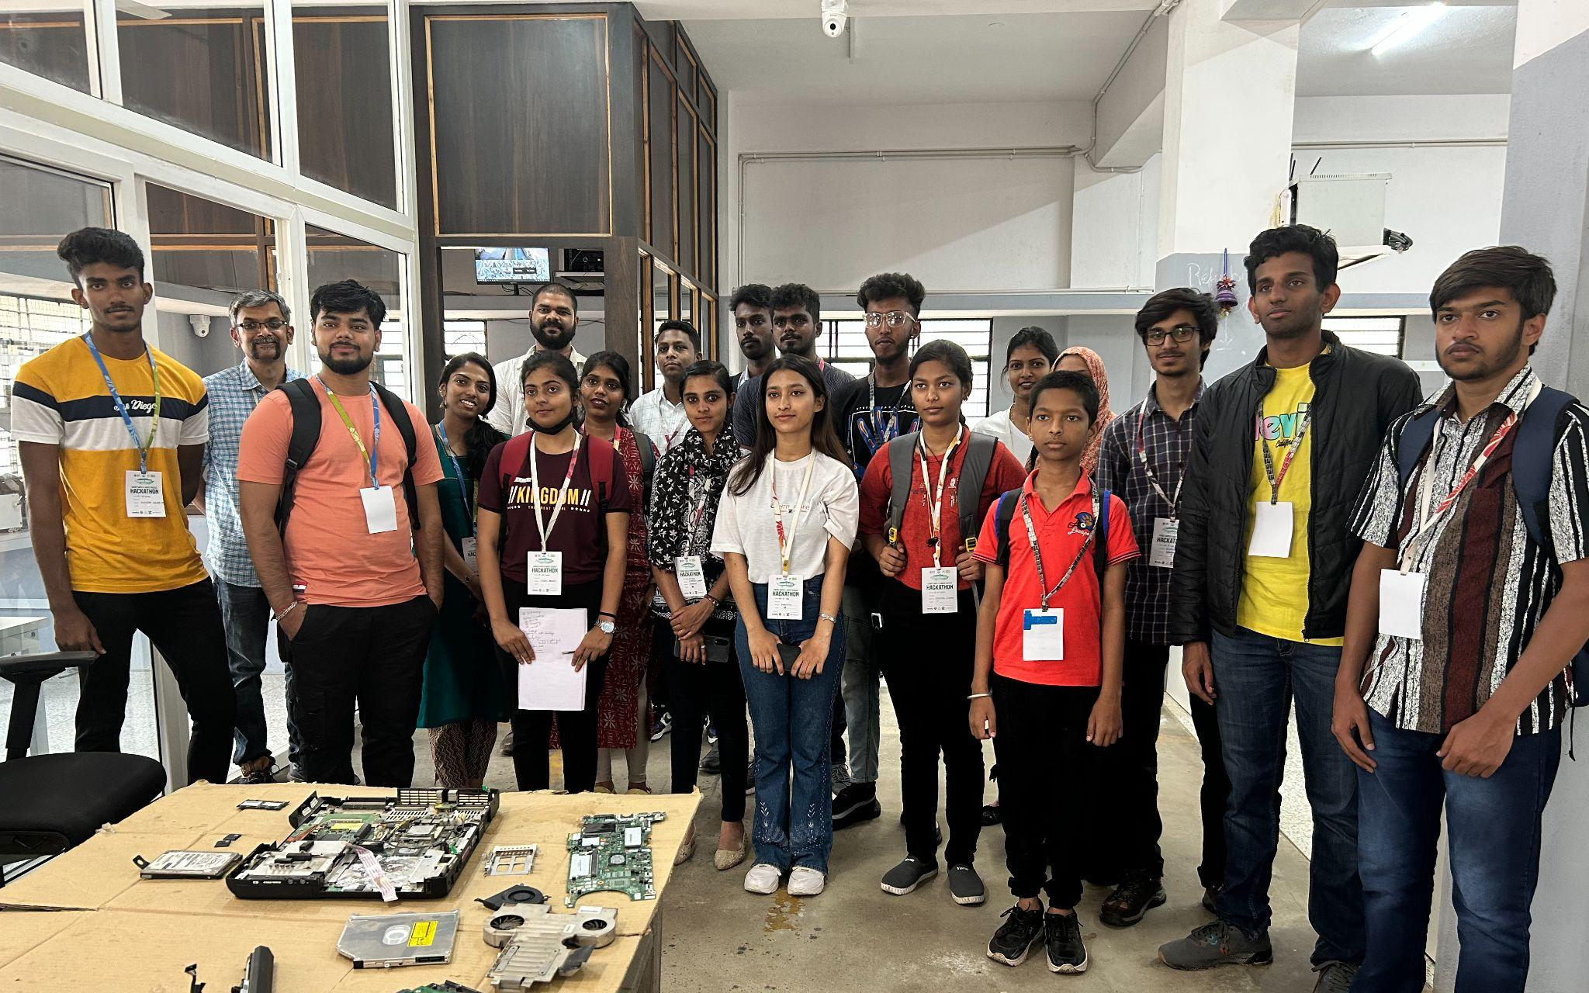
“The site was quite traditional and not modern and the workers, especially women, were professional at their work giving full effort. The decorum of the site was amazing and we as the students have gained much knowledge learning new things and meeting new people.”

SDGs in Focus
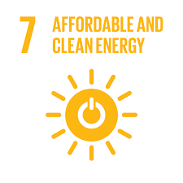

SDG 7: Ensure access to affordable, reliable, sustainable and modern energy for all

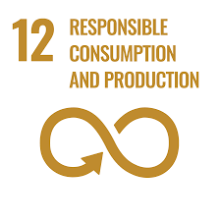

SDG 12: Ensure sustainable consumption and production patterns

Top Projects of the Event
THEME: E-WASTE
Impact Potential: In India, it is estimated that 67% of E-waste is disposed of in an informal and unregulated manner. A solution implemented at large scale for e-waste in India has the potential to bring down the environmental and health issues, for example, if 100% of e-waste was recycled, it would prevent the release of approximately 1.7 million tons of lead, 100,000 tons of mercury, and 30,000 tons of cadmium into the environment. This would have a significant positive impact on public health and the environment.

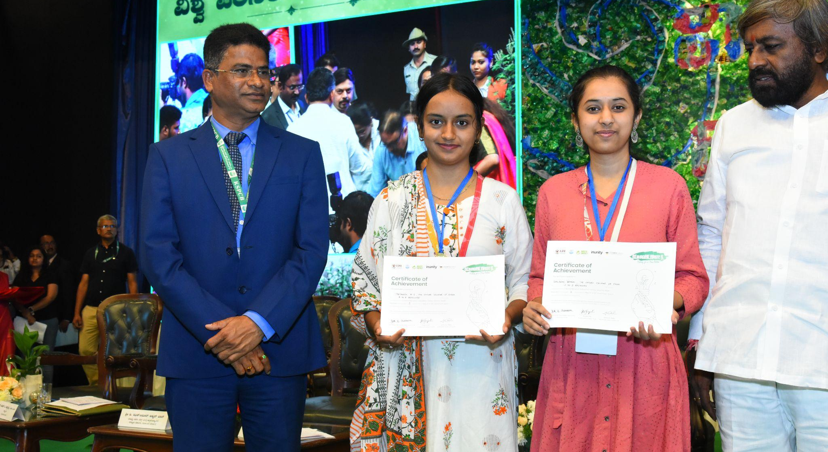
Winners: A to Z recyclers
Organisation: The Oxford College of Engineering & Samvada
Solution: The team intends to collect E-waste from origin companies by utilising an app, as the companies sell their electronic waste to them. It is then transported to city centres for dismantling, and the resulting components are then forwarded to recycling industries.

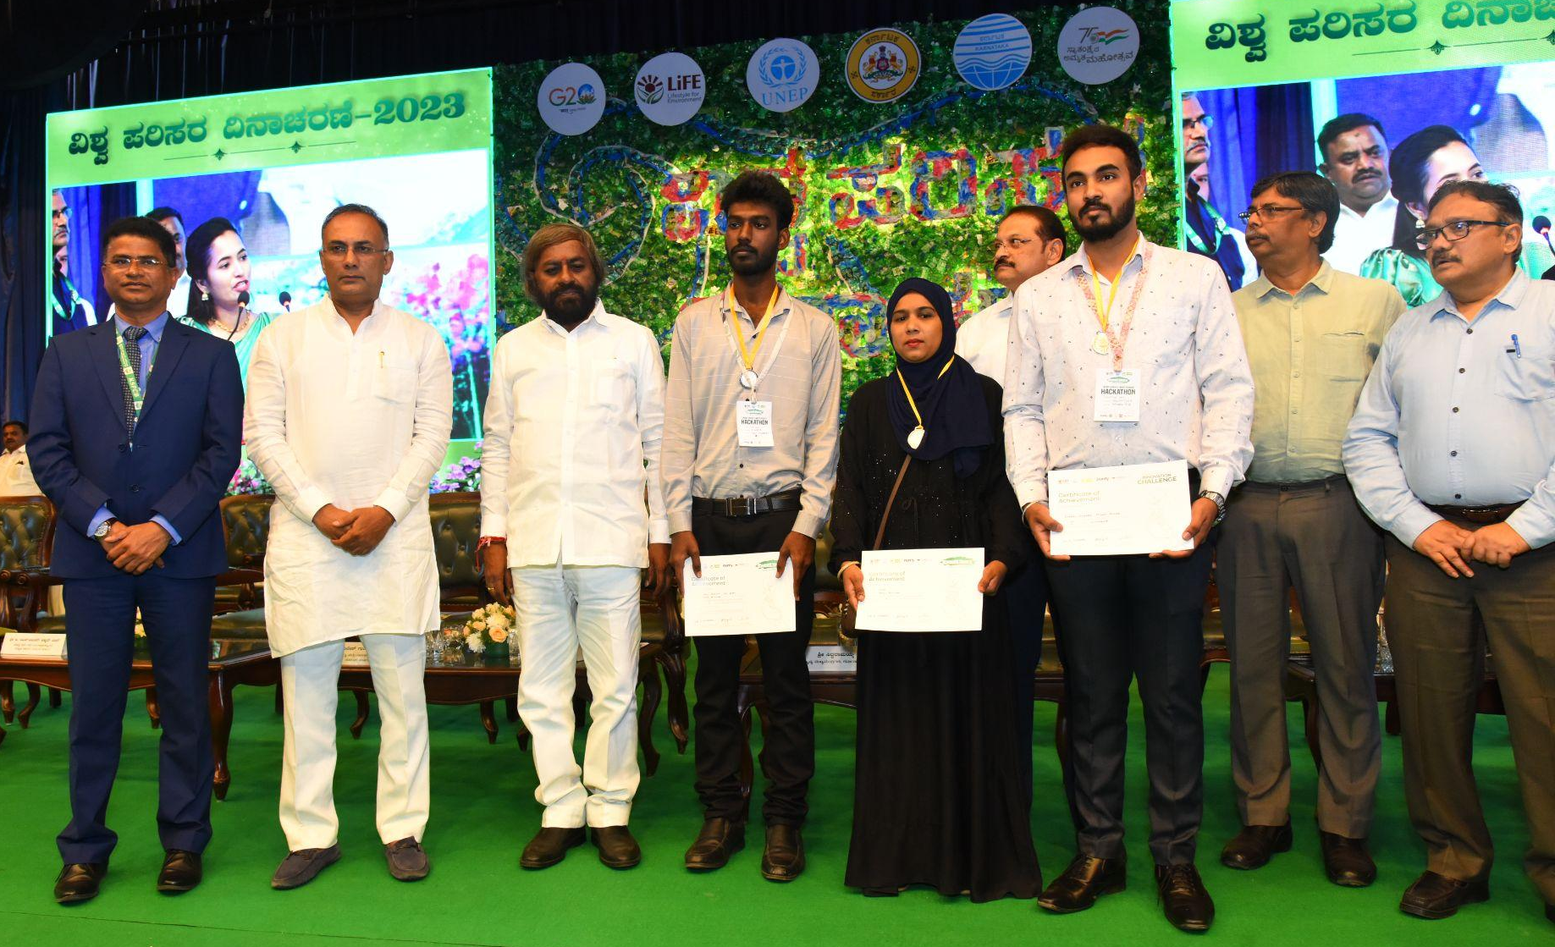
Runner Up: RenewRecyclers
Organisation: DBT, BIRAC
Solution: Creating Value through End-of-Life Management for Aging and Defective Solar Panels

Innovation Challenge Winners
Winner: Ms. Neha Clare Minj
Organisation: Global Institute of Technology, Bangalore
Description of the idea: An energy and environmentally conscious method for economically extracting metals from electronic waste.

THEME: ENERGY SAVED
Impact Potential: India is the world's third-largest energy consumer. This is expected to increase to 2.8 trillion kWh by 2040. This increase in energy demand will put a strain on the country's energy resources. According to the International Energy Agency, if India implements large-scale energy saving solutions, it could reduce its greenhouse gas emissions by up to 1.5 billion tonnes by 2040. This would help to mitigate climate change and improve air quality. Additionally, large-scale energy saving solutions would create jobs in the clean energy sector, which would promote economic growth in India.
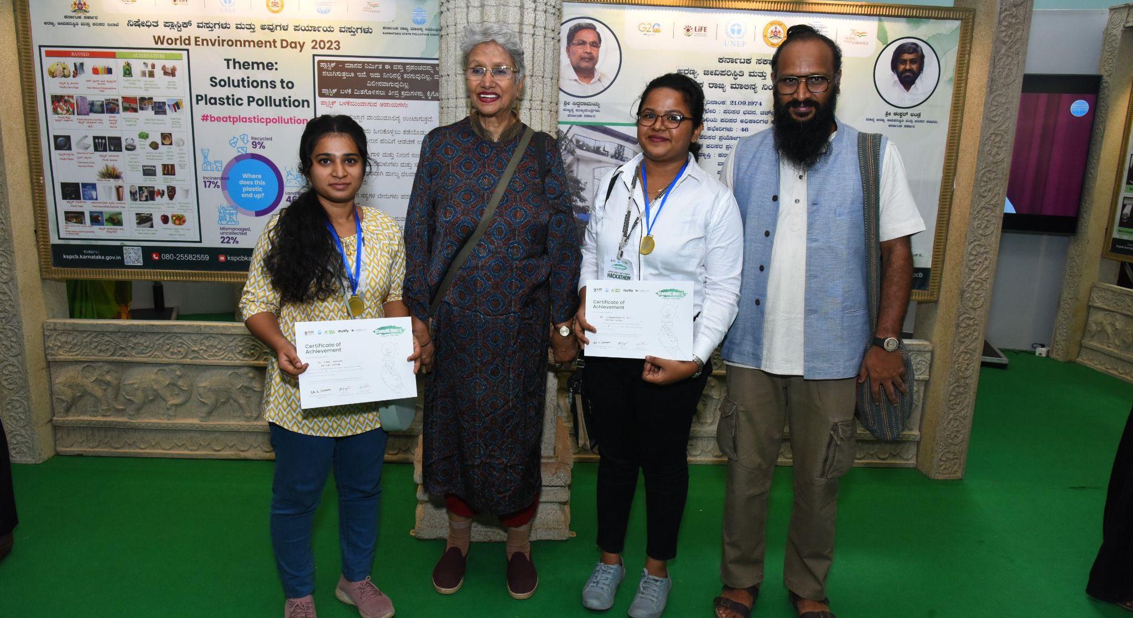
Hackathon Winners

Winners : Bio Fuel Futura
Organisation: Sarada Krishna Homoeopathic Medical College
Solution: Producing renewable biofuel from algae

Innovation Challenge Winners
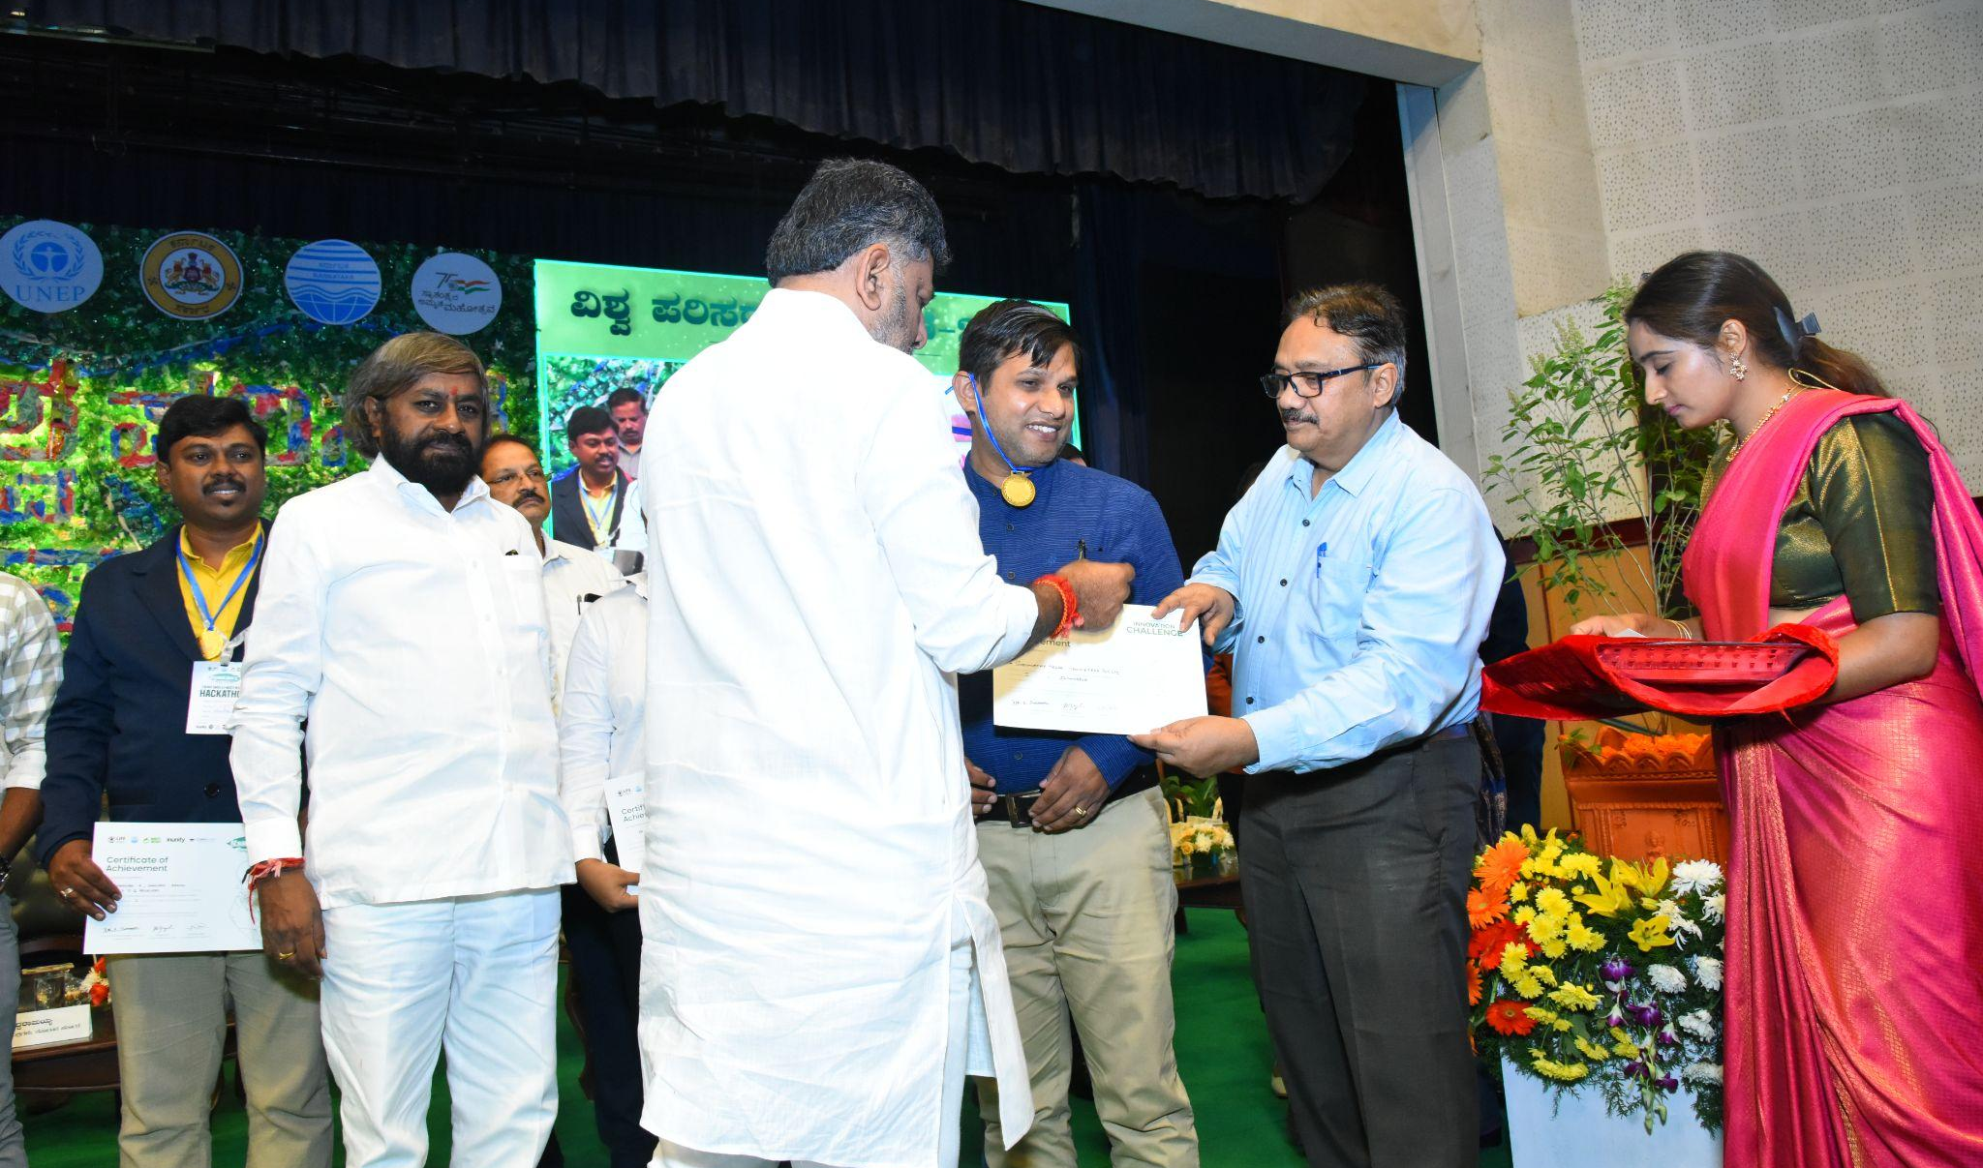
Winner: Dr. Gurumurthy Hegde
Organisation: Adindistech Private Limited.
Description: Adindistech Private Limited is providing cutting edge research products and solutions to the industry partners.

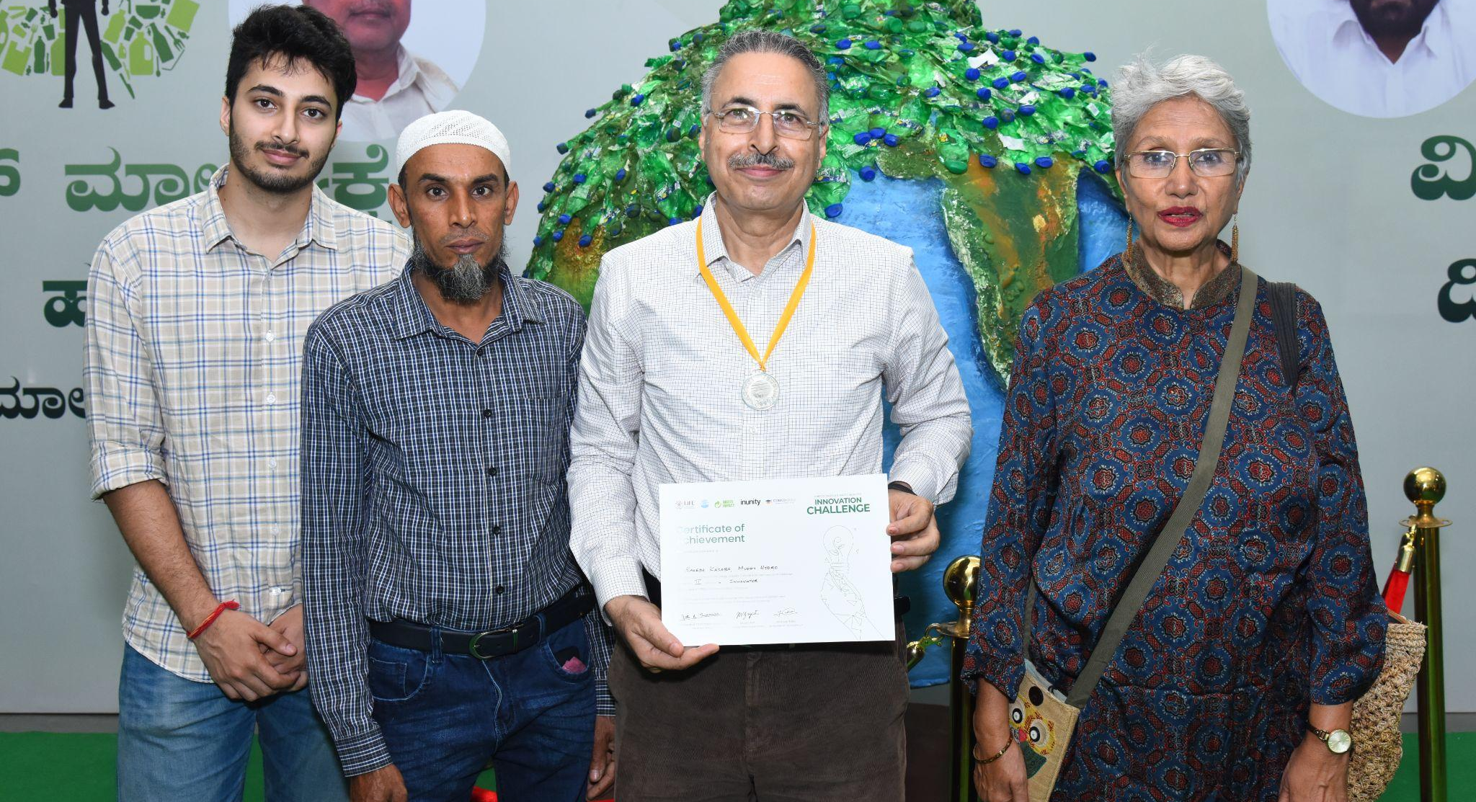
Runner up: Rakesh Kasaba
Organisation: Muddy Hydro
Description: Muddy Hydro specialises in developing micro-mini hydro plants with designs that are flood and sediment friendly.

Voices of Praise: Participant & Guest Organizations
“From the beginning of field visit to the in-between sessions from mentors and overnight hackathon until the final day at Banaswadi National College it was just mind-blowing. Huge respect for all you guys there! Organisers and Volunteers were great, supportive throughout!” - Rumaan Sharief N
“It was wonderful .I have attended many hackathons but it was totally different in a positive way. I hope you will organise such a hackathon again.” - Mohammed Fahad Khan
“It gave many connections and use of hubs. I’ll mould my idea into a startup. That confidence is because of this event.” - Dr. Sivaraman Pragathi R.S

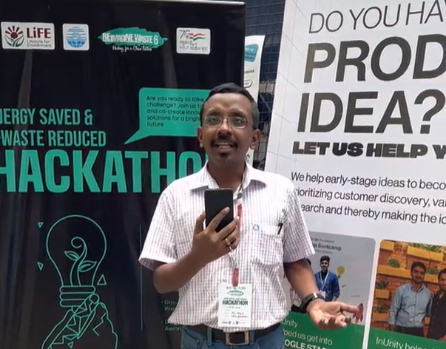
“It was a pleasure attending this event, seeing new minds who are into E waste reduction and energy efficiency” - Mayur, Mentor Selco Foundation

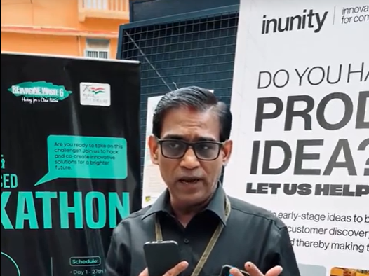

“Waste management has to be brought forward as a major sector and we need more and more millennials to join hands to bring big change.” - Mr. Sarvottam Pejavar, Founder Zycomy
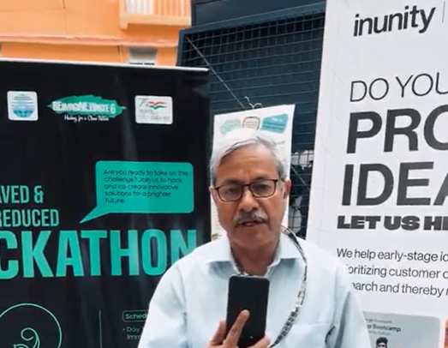
“The ideas generated and the ideas, some of which have been converted into prototypes and some are in the little scaling up stage really impressed me!” -Mr. Shubash Nayak, Acelor Mittal Steel
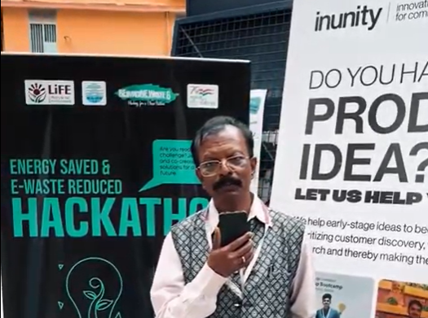
“I am astounded to hear that one of the members here is connected with over 10000 NGOs working in this regard, which is a good step!” -

Partnering Entities
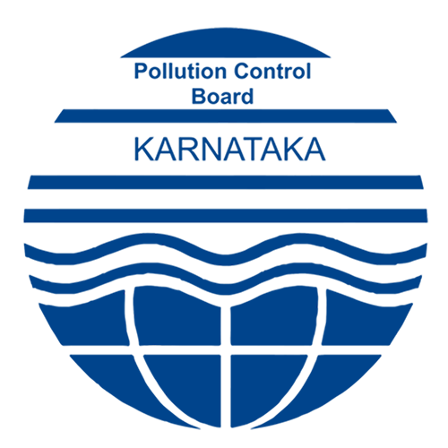
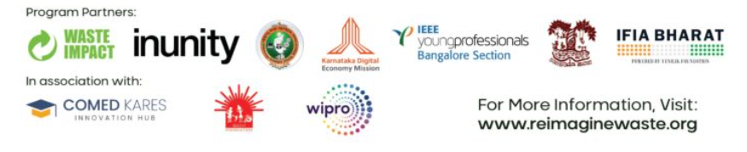
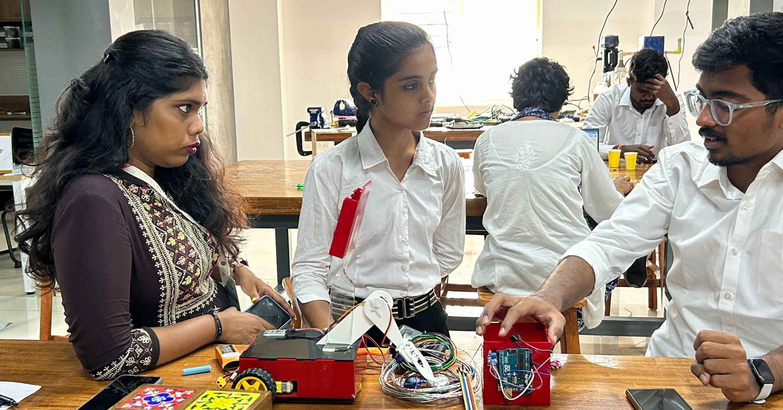
Way Forward!
- 45 days mentoring opportunity to access high-touch business mentors & sector mentors to guide teams to build their prototype.
- The graduating teams present their prototypes to investors, VCs & incubators to support ideas till the implementation stage.
- The top teams from this phase will be receiving seed fund support of 1 lakhs to build their MVP.
InUnity’s partnership with Waste Impact Trust enabled us to work closely with the E-Waste and Energy sector, contributing towards our activities in the Climate Action space for 2030. As a result of the program’s success, InUnity has successfully onboarded two potential partners, Wipro and Selco, with the continued interest of Waste Impact Trust for future programs supported by ComedKares.
Be at the forefront of similar initiatives. Join forces with InUnity!
Contact Details Follow us for more updates
Email : hithaishy@inunity.in
Phone : +91 9481247095
Website : www.inunity.in
Mangalore Office (Main Office):
5th floor, Main Building, Sahyadri Campus,
Adyar, Mangalore- 575007

